# Operating system 2 project word statistics

# Project description

1. Problem Modeling

- Mian thread identify text files in directory and its subdirectory (one or two level) and show them in GUI

- Each thread explores one or more text files

- No. of threads is based on number of processors (core)

- Each thread should send updates to GUI

1. GUI

- Input

* Directory path (or selection via

browse button)

* Checkbox for including subdirectories

- Output

* In table form:

▪ #words

▪ #is

▪ #are

▪ #you

▪ Longest word per file

▪ Shortest word per file

▪ Longest word per directories

▪ Shortest word per directories

- Note that updates should be in real time.

## Constructor and file processing class

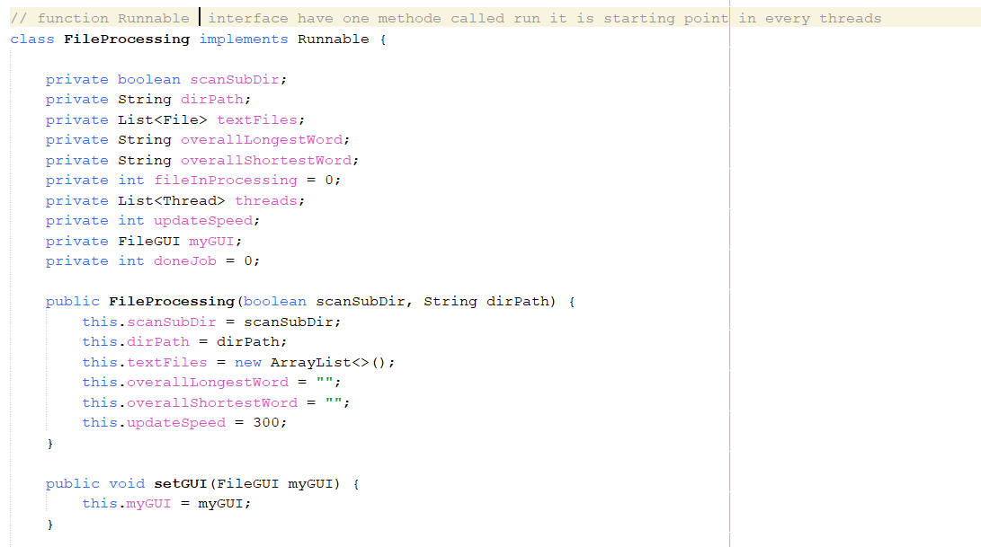

## initializeTextFiles and scanDirectory

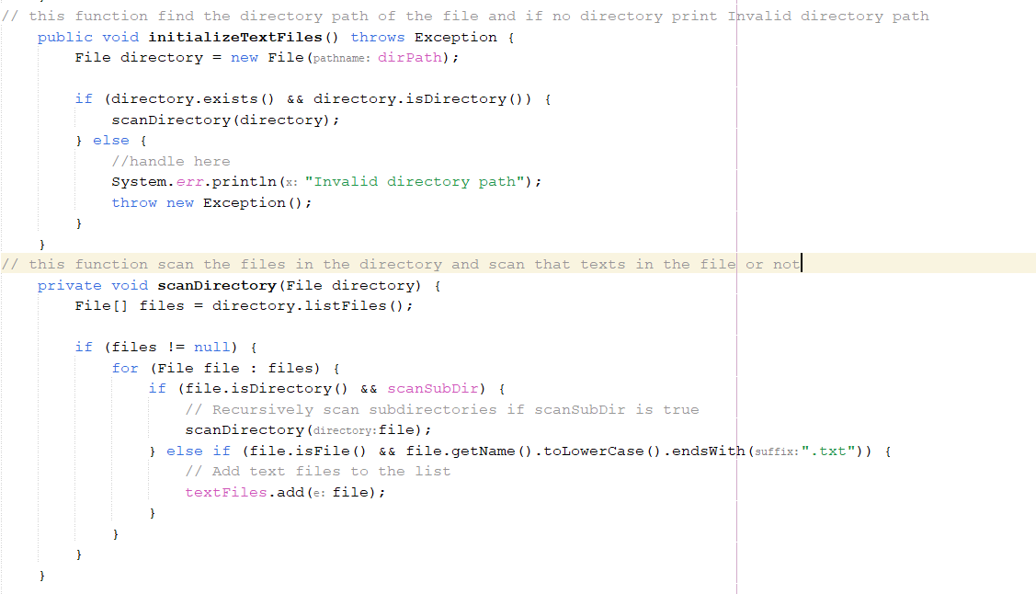

## 

## findLongestAndShortestWordsWithCounts

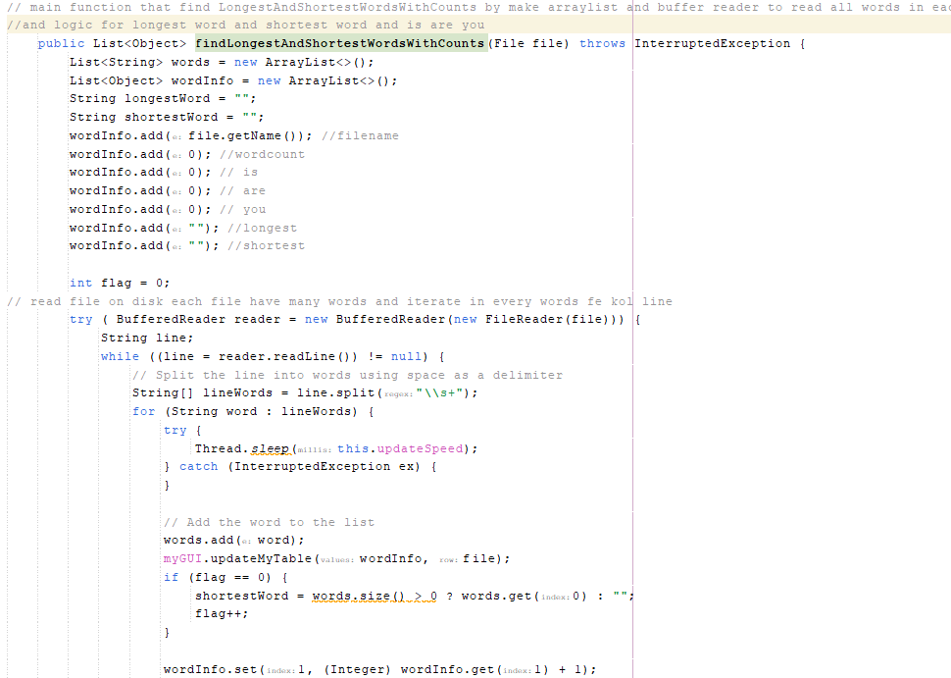

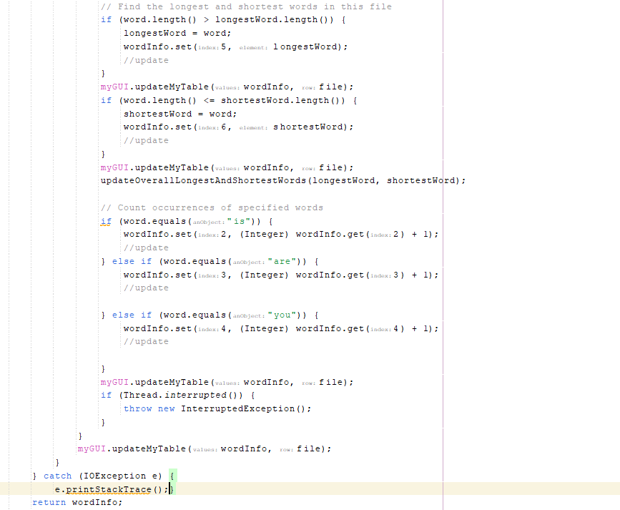

## updateOverallLongestAndShortestWords

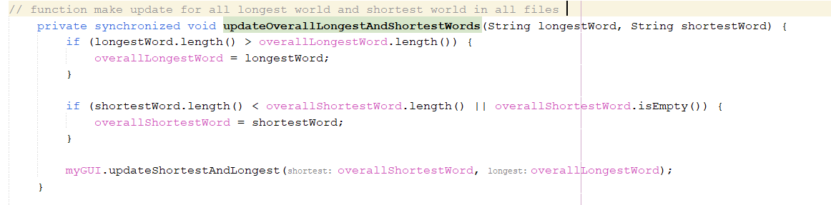

## printFileInfo()

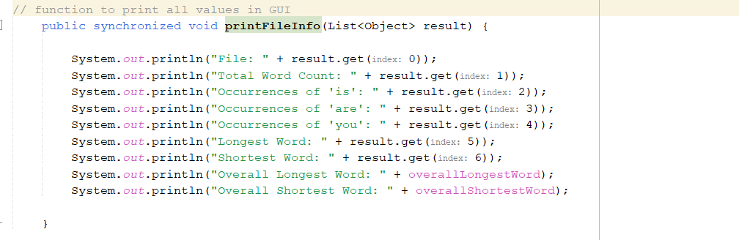

## Run()

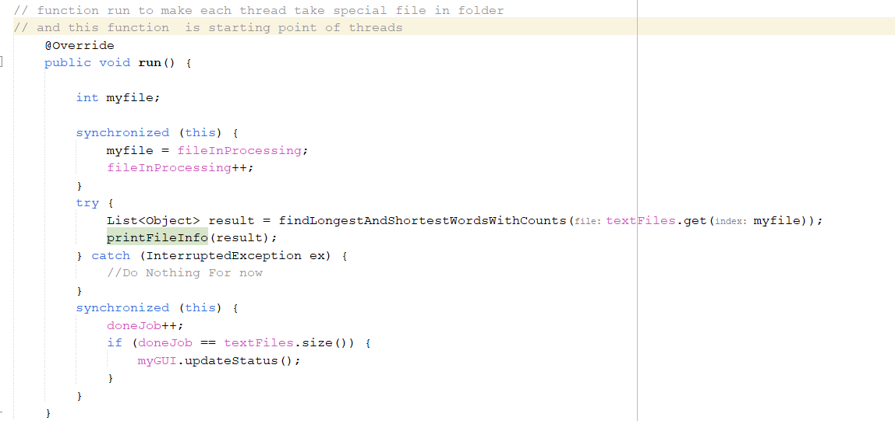

## Readyprocessing

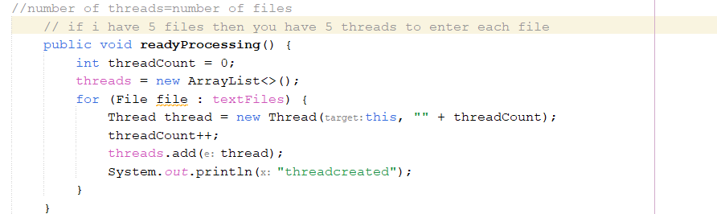

## Startprocessing

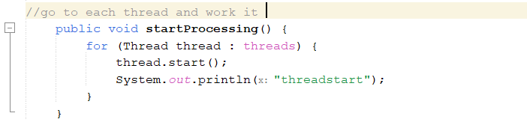

## The main function

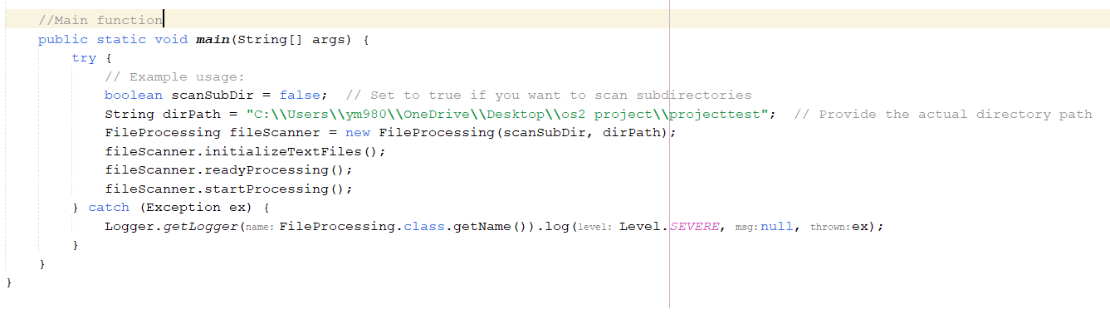

## 

## The GUI of the project

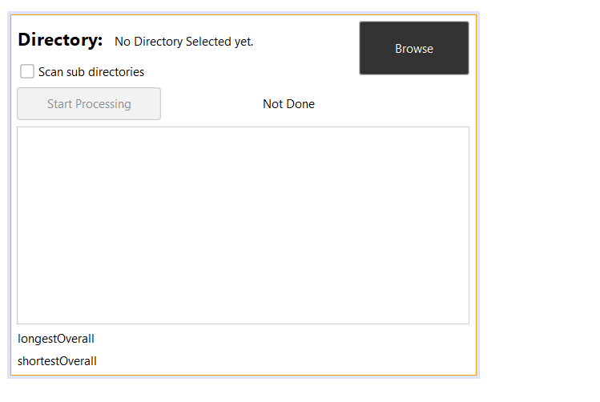

* The browse to find the file to start processing on it
* Directory is label to print you the name of file
* Scan sub directory is a check box if you have folder in the parent folder you must true the scan sub directory
* Start processing buuton to start threads to enter each file

## The words in test1 file

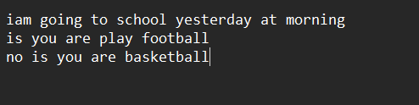

## The words in test2 file

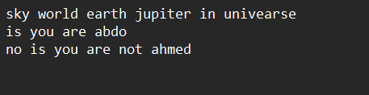

## Output of GUI

## 

## Team members roles:

**Logic of code : yassin mohamed yassin, Anas Saleh Moussa.**

**GUI: Anderw Atef, Anderw Sherif.**

**Testing the code :Nada Eissa, Manar Mustafa.**

**Documentation: Yassin Mohamed.**